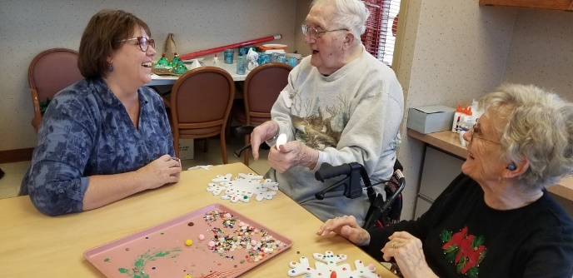
1022 Club
Services Provided

◊ Services offered at the 1022 Club may include, but are not limited to:
◊ Health assessments by an RN on admission and at periodic intervals
◊ Medication supervision and administration
◊ Family and physician updates if requested
◊ Medically ordered diet and snacks
◊ Evaluation by Adult Day Center activity personnel
◊ Individually tailored recreational therapy
◊ Group activities with social interaction
◊ Bath services with shampoo available
◊ Physician ordered therapy via PT recommendations
◊ Flexible hours, Monday-Friday. Not available on holidays or weekend
◊ Assistance in facilitating doctor or hospital appointments at health facility of the family’s choosing
◊ Education on disease and medications as needed to members and families
◊ Referrals to other community resources to assist member and family as needs are identified
◊ Threshold Adult Day Care does not provide transportation, but coordinates with existing services

